Online school portal
https://students.jmhs.com/
Username: Carriegilles@ymail.com
Password: 133Pinson

Log in
Click on English 4: Part 1 General Program
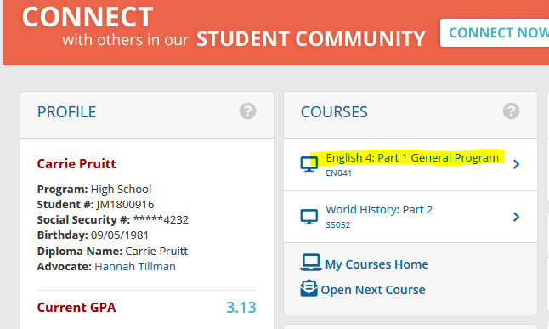

Assessments
- Quizzes
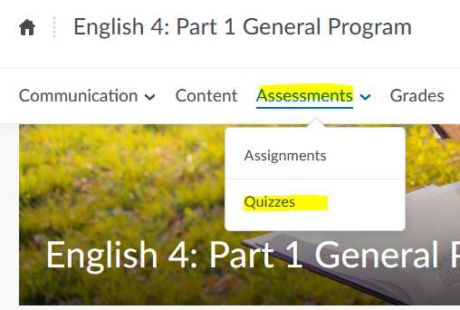

All 4 quizzes will populate
- Click on each one and answer all questions

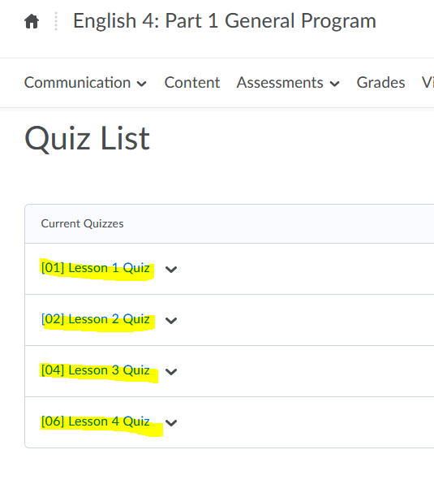

If you need any help,

Click on the content tab next to assessments and it will give you further information on the course

